Make the logo visible
Make the menu in the same header instead of a new one
Make the header menu like myntra.com
Footer make it nice
Make the inside button colours to Purple than blue
Need a demo site login – to show to the investors. I will add the employee details in this location login. Also I will use this login to make promo videos.
Please put the company name of the login we are creating in the header.
Menu Options
- Employees
- Leave
- Booking
- Tasks
- Timesheets
- Payroll
Employee page corrections
- Import is not working – don’t put buttons that don’t work
- Employee view page
  - Employee Details – spelling wrong
  - Make the strip more nice – it is looking dull now
  - Change the button colour from green. Next button
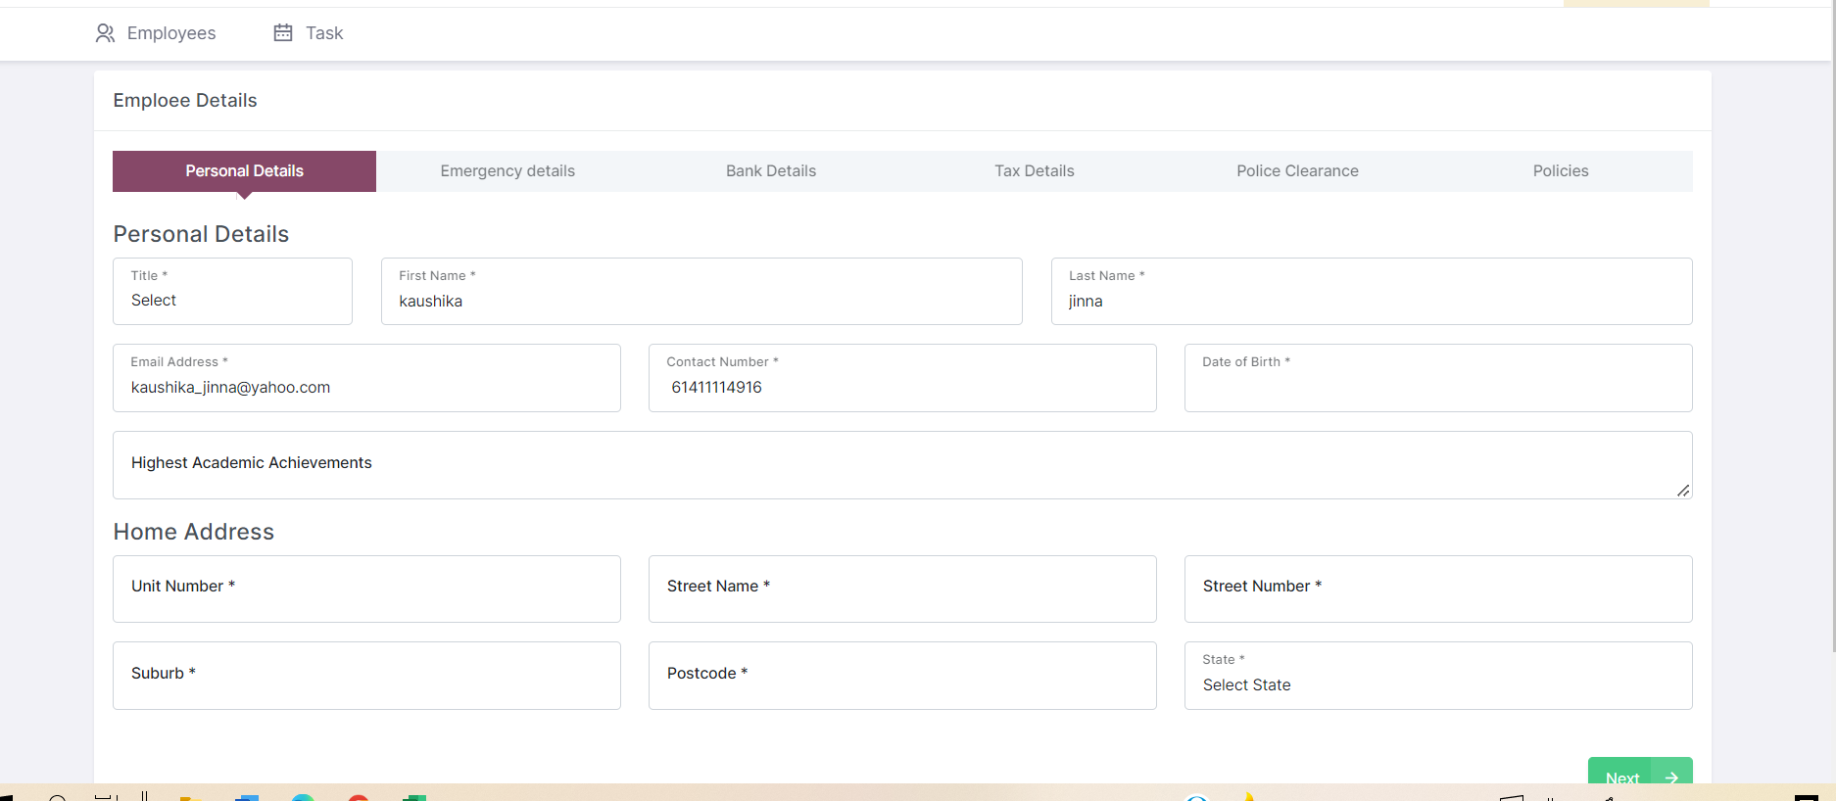

- Remove zouki word from below
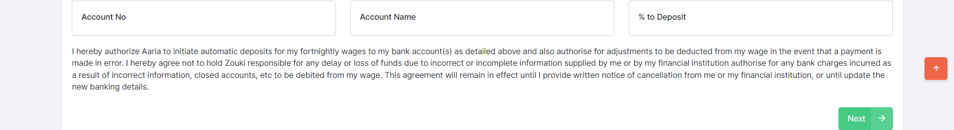

- Tapping on the tabs also should allow to open that page.
- Company policies page – I read checkbox is not clear and visible – ui to improve.
- From view page – I need to navigate back to list page with back button
- I have checked the checkbox in edit for company policies however it is not letting me save. Also all validation messages instead of green put them in red and nice bold with icon to know they are validation messages.
- Tab text should be bold and nicely visible. Make it attractive below screenshot. Headings, tab text – right now looks basic.
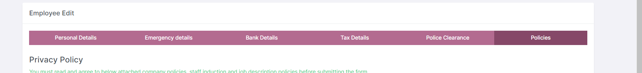
- It is not privacy policy in the above screenshot. It should be Company Policies and Procedures.
- Even edit should have a back button and save button
- Delete not working.

Task List
This figures are wrong fix it

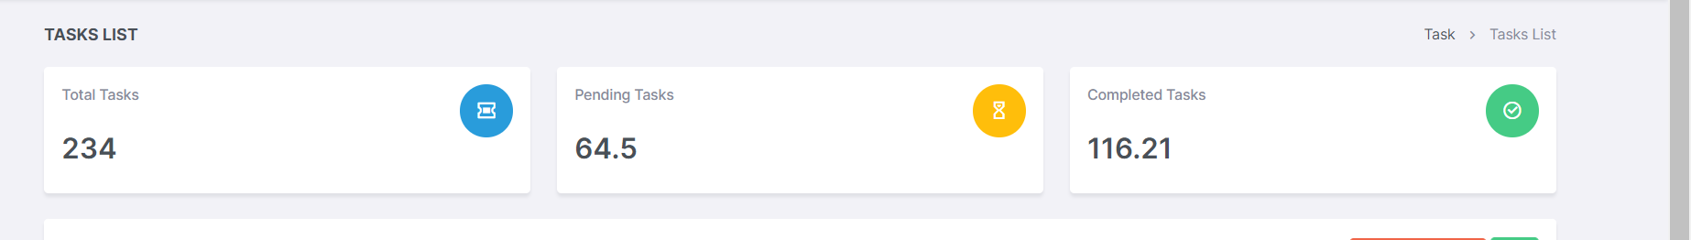

Date range filter not working
Task page should have a back button to go list page
When you change status popup to tell it is updated. Is this time tracking correct?
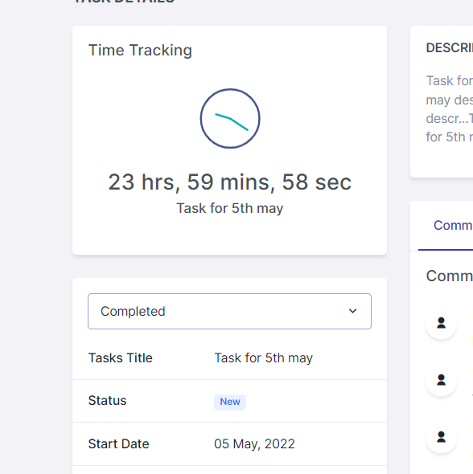

Edit unable to change the dates as shown below

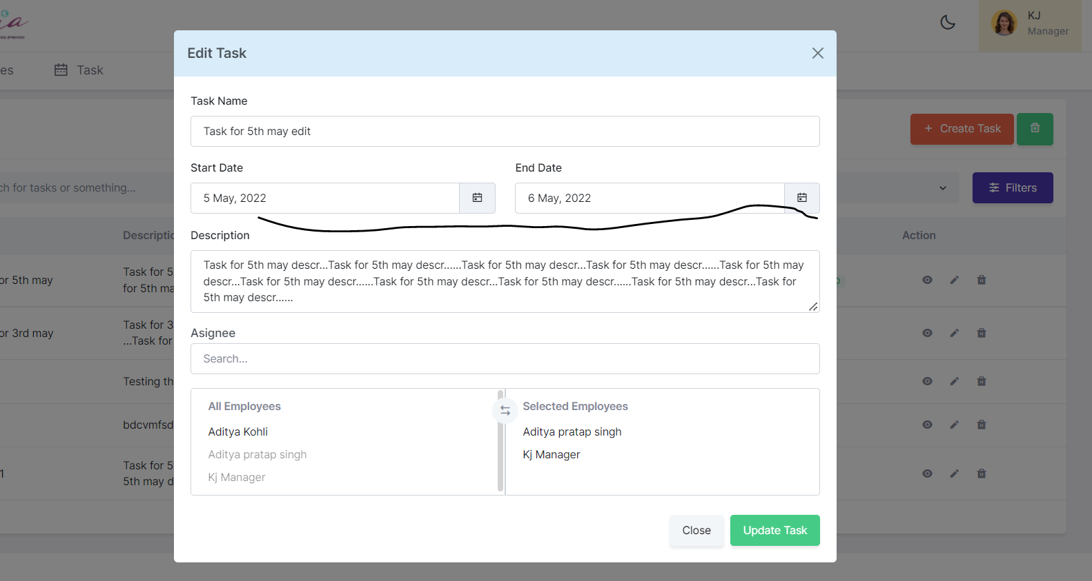

Not iphone compatible now
Add task calender icons not working either
Assignee not working
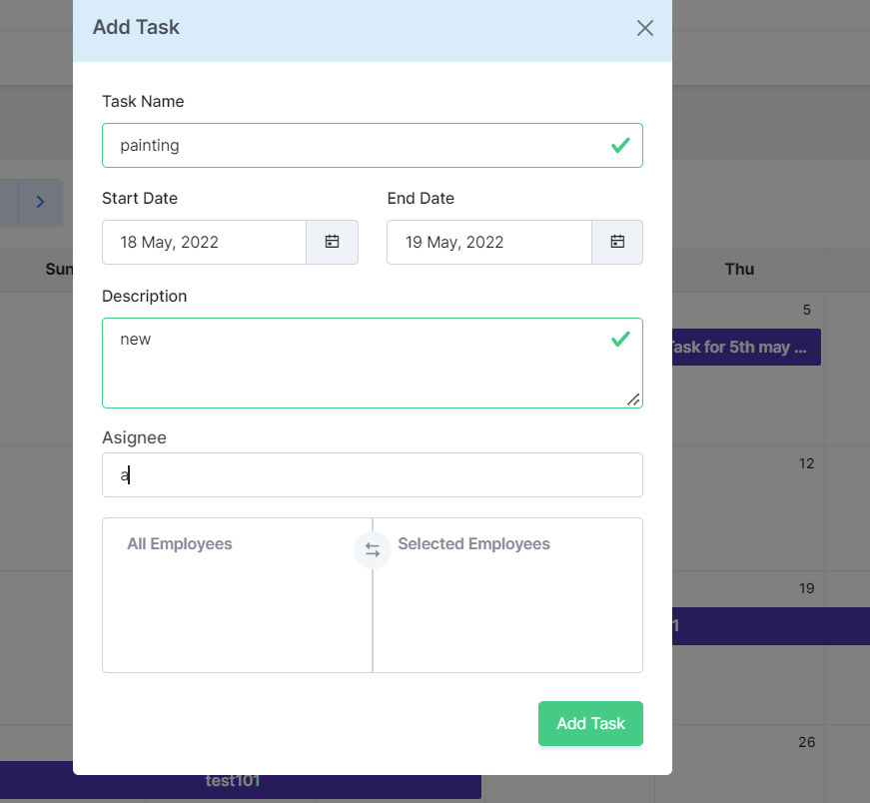
If there is no availability of employees then add task should tell the user to double check than leaving the assignee page blank.
Complete manager and employee portal

